BLOCKCHAIN-BASED DECENTRALIZED CLOUD STORAGE WITH RELIABLE DEDUPLICATION AND STORAGE BALANCING
Abstract:
In recent years, cloud storage has become a vital service for individuals and organizations to store and access data remotely. However, traditional cloud storage systems are centralized, exposing data to risks such as single points of failure, data breaches, and unauthorized access. This paper proposes a blockchain-based decentralized cloud storage system that addresses these limitations. The system incorporates reliable data deduplication and intelligent storage balancing to ensure efficient space utilization, security, and performance. Blockchain technology enhances transparency, immutability, and trustworthiness, while decentralized architecture distributes storage across multiple nodes to increase availability and resilience.
Existing System:
Traditional cloud storage solutions such as Google Drive, Dropbox, and Amazon S3 operate in a centralized architecture. In these systems, data is stored in data centers managed by a single service provider. Users upload their data, which is stored and accessed through centralized servers. These platforms often offer some level of deduplication, where identical files or data blocks are stored only once to save space. However, the deduplication process is managed by the service provider, which has full control over user data.
Storage balancing in centralized systems is typically handled by internal load balancers that distribute storage loads across different data centers or servers. However, users are often unaware of how and where their data is distributed, raising concerns about transparency and control.

Proposed System:
The proposed system utilizes blockchain technology to create a decentralized cloud storage infrastructure that enhances data security, transparency, and reliability. In this system, user data is encrypted, fragmented, and distributed across multiple nodes on a peer-to-peer (P2P) network. Each transaction or data update is recorded on a blockchain, ensuring integrity and traceability.
Reliable deduplication is achieved through secure hashing techniques and content-aware mechanisms that identify and eliminate redundant data while maintaining privacy. The deduplication process is decentralized and transparent, ensuring that only unique data is stored without compromising user confidentiality.
To achieve storage balancing, the system uses smart contracts to monitor node availability, capacity, and performance, dynamically distributing data to maintain an optimal load across the network. This prevents overload on individual nodes and enhances the overall efficiency and scalability of the system.
System Architecture:

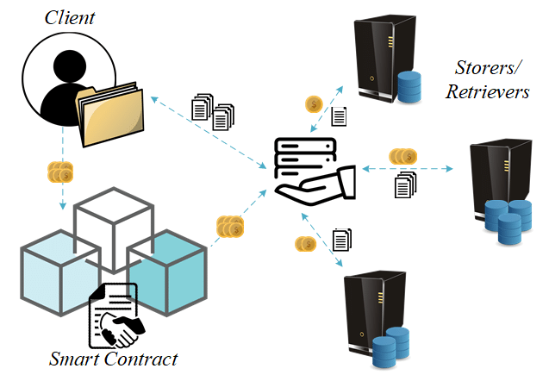

SYSTEM REQUIREMENTS:

HARDWARE REQUIREMENTS:

• System : Pentium IV 2.4 GHz.
• Hard Disk : 40 GB.
• Ram : 512 Mb.

SOFTWARE REQUIREMENTS:

• Operating system : - Windows.
• Coding Language : python.

